California Native Grasslands Association: Learning About California Grasslands
Lesson Title: What Was Here Before?
Grade level: Middle school
Lesson Length: 45-60 minutes for video and worksheet completion
Preparation and Materials: CNGA “What was here before?” video, pencils
Lesson Goal: Students learn about California grassland habitats, the species that live in them, and why they are important to wildlife as well as humans.
Lesson Description: Teacher plays and guides students through the video, helping to define vocabulary and going over key concepts. Students complete worksheet by answering questions using knowledge from coursework and information from the video.
Lesson Objectives: Students interpret information from a video lesson and apply concepts from coursework to answer questions and draw conclusions.
Lesson Background:
Grasslands are defined as habitats made up of low growing plants (mainly grasses and forbs) with few trees or shrubs. In California, grasslands are an important ecosystem and cover almost 20% of the state. There are many types of grasslands in California, ranging from coastal prairies to working rangelands to alpine meadows. California grasslands were historically composed of native perennial bunchgrasses interspersed with a highly diverse flora of other plants. However, modern day grasslands usually contain many species of exotic annual grasses and weeds introduced from other areas. Grasslands are important habitat for animals such as birds, insects, amphibians, reptiles, and mammals, including many rare and endangered species. Grasslands are also used by humans to graze livestock which produce meat, milk, and clothing materials. In addition, grasslands provide ecosystem services such as filtering and storing water from precipitation, sequestering carbon, and preventing soil erosion.
Vocabulary Words:
Burrow - (n.) a hole or tunnel in the ground dug by an animal to use as a dwelling. (v.) the act of digging such a hole or tunnel
Grass - type of plant that is low-growing with long, narrow leaves and usually hollow stems
Grassland - an open field of low-growing plants
Forb - a broad-leafed herb
Rushes and sedges - grass-like plants that grow in wet or marshy areas
Raptors - birds that hunt and feed on other animals

“What was here before?” Worksheet Name: _______________________________________

- What is a grassland? What types of plants grow in a grassland?

- Name 2 specific plants that grow in California grasslands

- Name a large mammal that lives in California grasslands

- What is an example of a bird that lives in California grasslands?

- Name 3 types of grassland animals that live in burrows underground. Do all animals that live in burrows make the burrows themselves?

Critical Thinking
- Why is protecting grasslands important? Discuss what products we get from grasslands and what environmental benefits grasslands provide.

- Use the word bank, along with what you learned from the video and your knowledge of energy and food webs, to label the following diagram:

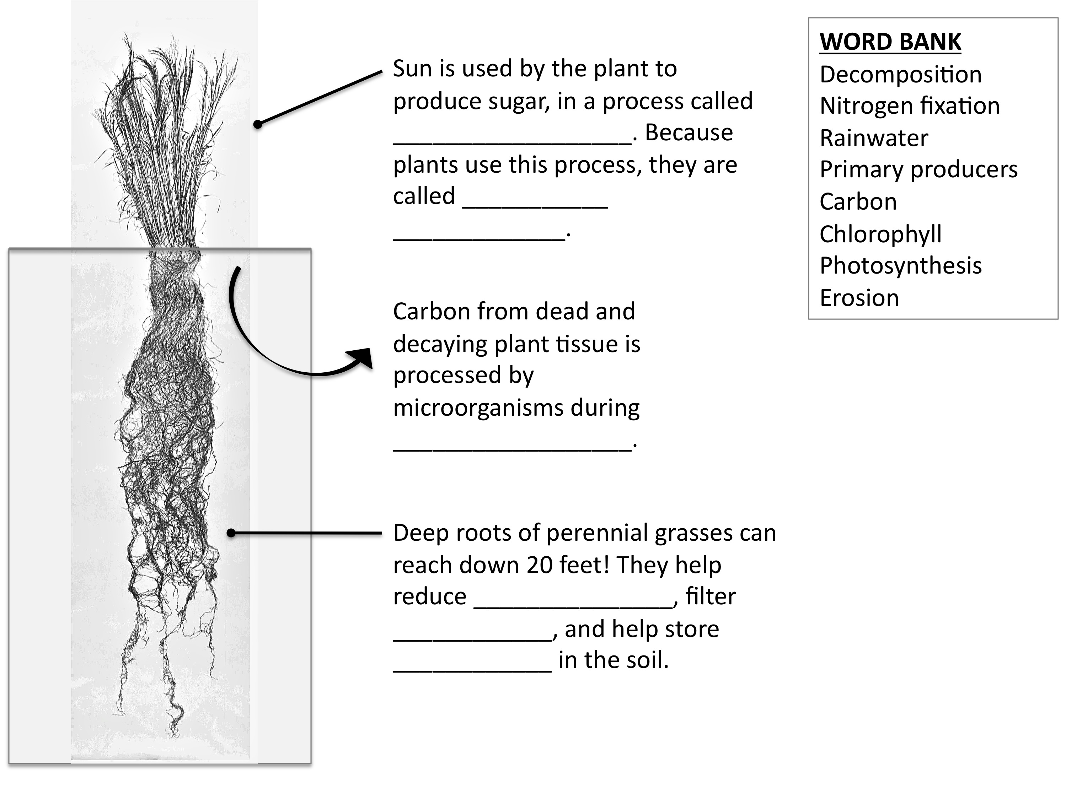

“What was here before?” Worksheet – Teacher’s Key

- What is a grassland? What types of plants grow in a grassland?
A grassland is an open field of low-growing plants, containing wildflowers (or “forbs”), grasses, sedges and rushes

- Name 2 plants that grow in California grasslands
Yampah, mariposa lily, clover, poppies, purple needle grass, California brome, or Idaho fescue

- Name a large mammal that lives in California grasslands
Deer, tule elk
- What is an example of a bird that lives in California grasslands?
Western meadowlark, savannah sparrow, horned lark, grasshopper sparrow, mourning dove, chestnut-collared sparrow, northern harrier

- Name 3 types of grassland animals that live in burrows underground. Do all animals that live in burrows make the burrows themselves?
Examples: Ground squirrels, gophers, kangaroo rats, badgers, tarantulas, toads, salamanders, burrowing owls, gopher snakes, weasels.
Not all animals make their own burrows; some, such as burrowing owls and tiger salamanders, use burrows made by other animals like gophers and ground squirrels.

Critical Thinking
- Why is protecting grasslands important? Discuss what products we get from grasslands and what environmental benefits grasslands provide.
Humans use grasslands for grazing cows, sheep, horses, etc. We produce milk, meat, wool, and leather from these animals. Grasslands also help filter rainwater, produce oxygen, and store carbon. They provide habitat for many types of animals including mammals, birds, insects, and reptiles.

- Use the word bank, along with what you learned from the video and your knowledge of energy and food webs, to label the following diagram:

Answers: Photosynthesis, primary producers, decomposition, erosion, rainwater, carbon.

